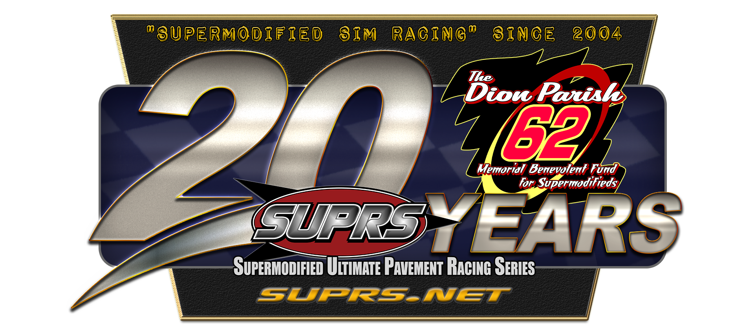

2023-24 - 20th Anniversary Gold Crest

Wing Supermodified Championship XX Schedule
Racing Tuesday Evenings by 9:00pm ET Except Where Noted
Race | Date | Event | Track | Laps | Details
1 | 10/03/23 | 20th Annual Harvest of Speed Season Opener | LaPorte Speedway*-IN | 75 | NH;W;SC;ISC; D
2 | 10/10/23 | 20th Annual Dion Parish Memorial | Kalamazoo Speedway-‡‡-MI | 62 | rF;W;SC;SGS
3 | 10/17/23 | 20th Annual North Carolina Swing RC1 | Dasera Speedway**-NC | 40 | NH;W
4 | 10/17/23 | 20th Annual North Carolina Swing RC2 | Orange CountySpeedway*-NC | 40 | NH;W
5 | Wednesday  10/18/23 | 20th Annual North Carolina Swing RC3 | Southern National Raceway Park-NC | 50 | rF;W
6 | Wednesday  10/18/23 | 20th Annual North Carolina Swing RC4 | Concord Motorsports Park-ü-NC | 50 | rF;W
7 | Thursday  10/19/23 | 20th Annual North Carolina Swing  RC5-The Hickory Hustle | Hickory Motor Speedway-§-NC | 75 | rF;W; BP; Top 8 NC Swing Pts Invited
XX | 10/20-10/28/24 | NO | RACES | OFF | WEEK
8 | Sunday  10/29/23 | Black Kat Klassic  Ohio State 500  R1 | New Bremen Speedway-_{J}-OH | 100 | rF;W; Crack the Whip;  OS5
9-11 | Thursday  11/02/23 | SUPRS 20th Anniversary Night | SUPRS Stafford Motor Speedway-CT | Triple 20s | NH;W;SC; RS; (PSTM, NHSM, SUPRS v6 mod)
12 | 11/07/23 | Veterans Day Special | New River Valley Speedway*-VA | 75 | NH;W
13 | 11/14/23 | 19th Annual Turkey Shoot | Memphis Motorsports Park- ^{µ}-TN | 40 | rF;W; Turkey Trot; Winner Receives Thanksgiving Turkey
XX | Thanksgiving | Break | 5pm 11/15/23 | to | 8am 11/27/23
14 | 11/28/23 | 20th Annual Wing Side Up Twin 25s | The Salem Speedway-¡-IN | 25 | rF; W; SCx2;SCCx2; DD; BP;ISC;  RS 2nd feature
15 |  |  | Winchester Speedway--_{J}--IN | 25
16-17 | Sunday  12/03 | The Sun Valley 40s | Anderson Speedway--_{J}--IN | 40x2 | rF;W; BP;ISC
18 | 12/05/23 | Empire State Super Series Blind Date Night! | NY Track** | 50 | NH;W-NHSM; ESS
19 | 12/12/23 | Christmas Special | Berlin Raceway-_{J}-MI | 25 | rF;W;ESS;Reindeer Dash  Winner Receives Christmas Ham
XX | Christmas | Break | 5pm 12/15/23 | to | 8am 01/02/24
20 | 01/02/24 | 20th Annual Crazy Canuck Snowball Derby | Delaware Speedway-_{CW}-ON, CAN | 50 | rF;W;BP;Canadian Pursuit
21 | 01/09/24 | 16th Annual Terry Gibson Memorial-Fast 50 | SUPRS Sandusky Speedway-OH | 50 | NH;W;TGS
22 | Wednesday  01/10/24 | 16th Annual Terry Gibson Memorial  Ohio State 500  R2 | SUPRS Sandusky Speedway-OH | 100 | NH;W;SC;SGS  OS5; BP
23-24 | 01/16/24 | Ohio State 500  R3-4 | Columbus Motor Speedway-_{J}-OH Lorain County Speedway-_{J}-OH | 100x2 | rF;W; OS5; BP
25 | 01/23/24 | Mid Season Championship | SUPRS Oswego Speedway-NY | 100 | rF;W;DP;D;ESS
XX | 01/26-02/04/24 | NO | RACES | OFF | WEEK
26 | Monday  02/05/24 | Florida Speedweeks Rc1 | SUPRS DeSoto Speedway-FL | 50 | rF;W; BP
27 | Tuesday  02/06/24 | Florida Speedweeks Rc2 | Black Creek Raceway*-FL | 25 | NH;W; BP
28 | Wednesday  02/07/24 | Florida Speedweeks Rc3 | Dodge Raceway Stadium-^{ǥ}-FL | 50 | rF;W; BP
29 | Thursday  02/08/24 | Florida Speedweeks Rc4 | USA Int Speedway-¡-FL | 25 | rF;W; BP
30 | Friday  02/09/24 | Florida Speedweeks Rc5 | 5 Flags Speedway-ʁ-FL | 50 | rF;W; BP
XX | 02/10-17/24 | NO | RACES | OFF | WEEK
31 | 02/20/24 | BMK Logistics Presidents Day Special | SUPRS Lee USA Speedway-NH | 75 | rF;W
32 | 02/27/24 | 15th Annual SUPRS All-Star Classic | SUPRS Star Speedway-NH | 200 | rF;W;SC; TCR
33 | 03/05/2024 | 19th Annual Keystone Nationals | Lake Erie Speedway-_{J}-PA | 50 | rF;W;BP
34 |  |  | Nazareth Speedway-^{µ}-PA | 25
35 | 03/06/24 | 20th Annual Randy Witkum Memorial 19th Annual Keystone Nationals | Jennerstown Speedway*-PA | 125 | NH;W; BP;SC;SGS
36 | 03/12/24 | St Patrick's Day Grab O’ the Green  Ohio State 500  R5 | Toledo Speedway-_{J}-OH | 100 | rF;W;OS5;BP
37-38 | 03/19/24 | 20th Annual Indyana Supermod Challenge presented by WAGs Custom & Cool Awards | Indianapolis Raceway Park-^{ǥ}-IN | 50x2 | rF;NW; W; DD;ISC; BP
39-40 | 3/26/24 | SUPRS Copper World Classic XX  Presented by Kern Motorsports | Phoenix Int’l Raceway-‡- AZ | 25x2 | rF;NW; W; BP
XX | EASTER | BREAK | 5pm 03/27/24 | to | 8am 04/02/24
41 | 04/02/24 | Jeff Russell Special | The Bullring at LVMS-ʁ-NV | 85 | rF;W;D
42 | Sunday  04/07/2024 | Golden State Classic R1-4 | Altamont Speedway--_{J}--CA | 100 | rF;W; GSC; BP
43 |  |  | Stockton Speedway--ʁ-CA | 100 | rF;W; GSC; BP
44 | Monday  04/08/2024 |  | Shasta Speedway-_{SPR}-CA | 100 | rF;W; GSC; BP
45 |  |  | Kern County Raceway Park- -CA | 100 | rF;W; GSC; BP
46 | 04/09/24 | 20th Annual Billy Vukovich III Classic  Presented by Supermodified Scorecard  Golden State Classic R5 | Mesa Marin Speedway*-CA | 100 | NH;W;D;SC;SGS; GSC; BP
47 | Sunday  04/14/24 | Golden State Classic R6 | Buckley Speedway**-CA | 100 | NH;W;GSC; BP
XX | 04/15-20/24 | NO | RACES | OFF | WEEK
20th | ANNUAL | SUMMIT | CLASSIC | 125 | WEEK
 | Monday 04/22/24 | Cherry Breaker 63(tent)) | SUPRS Madera Speedway-CA | 63 | NH; W  (Non-Points Race  Invite Only)
48 | Tuesday  04/23/24 | 19th Annual Summit Classic 125 TT/Heats | SUPRS Madera Speedway-CA | 10 | rF; W
48 | Wednesday  04/24/24 | 19th Annual Summit Classic 125  B-Main, Feature | SUPRS Madera Speedway-CA | 125 | rF; W; SC; TCR; GSC

KEY:
NH=NASCAR Heat, rF=rFactor,-W=Wing Supermodified, NW=Non-Wing Supermodified
*=TMS Member Modded Track, **=DSES Paved version, _{F} =Flash,
67=FreeWill67 version of this track, ǥ=Gater version. §=Stock Car Sim version,
ę=Evolution version, µ=FMS version, ĵ=JNS version, ‡=TPSCC version, ‡‡=Griff version,, ʁ=RFN version, ü=UKSOM version, _{CW} =Camden Wagner version, ¡=Sim Factory LLC version, _{j}=JCR Tracks version, _{SPR}-Sim Pro Racing Series

SC=SUPRSCharger SCC=SUPRSChallenge DD=Double Down RS=Random Start BP=Bonus Points DP=Double Points ESS=Empire State Super Series Event ISC=Indyana Supermod Challenge OS5=Ohio State 500 Series GSC=Golden State Classic Series
D=Fast Car Dash TCR=SUPRS Triple Crown of Supermodified Sim Racing presented by Icings on Top event
SGS=Summit 125 Guaranteed Starter TGS=Terry Gibson Memorial Guaranteed Starter
=Day Race =Night Race =Live Streaming

BE A SUPRS SPONSOR!
-All regular shows-
To sponsor a regular race, the price is the number of laps you wish to sponsor at $1.00 a lap. (ie-$50.00 for 50 laps)
To sponsor a race 51 laps or more, the price is $2.00 a lap. (ie -$200.00 for 100 laps).
Please contact us for more information on sponsorship of Title races, Marquee races, Multi-Race Swings, and Memorial races.

-DISCLAIMER-

THIS CONTEST SCHEDULE IS ACCURATE, TO THE BEST OF SUPRS ABILITY, AT THE TIME OF PUBLICATION ON 09/27/2022.

OTHER THAN THE START OF PRACTICE/HOT LAPS AND DRIVERS’ MEETING, ALL TIMES ARE APPROXIMATE AND ARE SUBJECT TO CHANGE.

SUPRS RESERVES THE RIGHT TO ADJUST CONTEST DATE, TIMES, ORDER, RACE FORMAT, MODIFICATION, PLATFORM, HANDICAPPING, LINEUPS, POINTS, AWARDS AND ORDER OF EVENTS, BASED ON CAR COUNT, TIME CONSTRAINTS, or OTHER EXTENUATING CIRCUMSTANCES WITHOUT PRIOR WRITTEN NOTICE.

SUPRS MEMBERS SHOULD REFER TO EMAIL NOTIFICATIONS, AND RACE DAY FORUM POSTS FOR UP TO DATE SPECIFICS ABOUT EACH EVENT.

FANS ARE ENCOURAGED TO VISIT THE SUPRS WEBSITE AND FOLLOW SUPRS SOCIAL MEDIA CHANNELS FOR UPDATED SEASON INFO.

