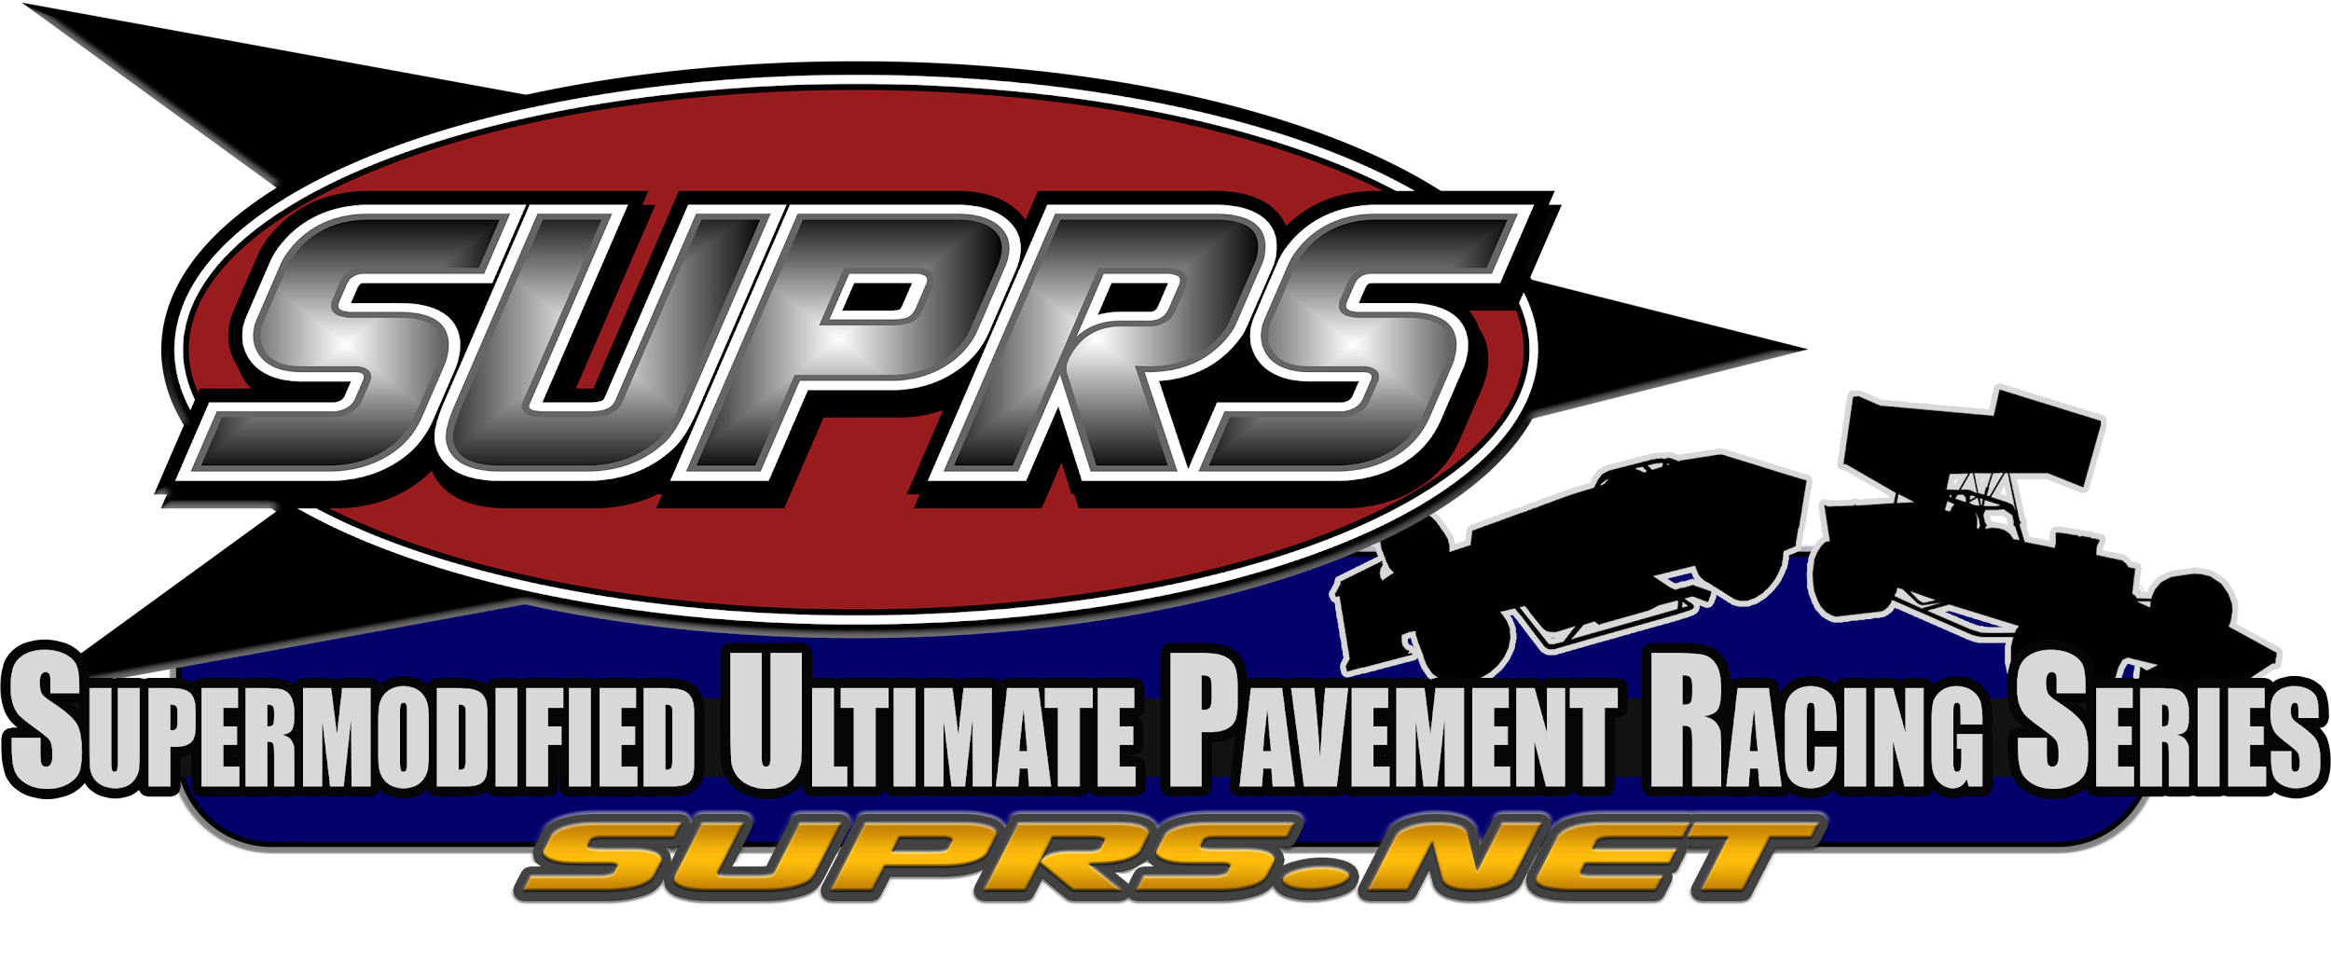

2025-26 - Gold Crest Wing Supermodified Championship XXII Schedule
Racing Wednesday Evenings 9:00pm ET Except Where Noted
Race | Date | Event | Track | Laps | Details
1 | 10/22/25 | 22nd Annual Harvest of Speed Season Opener | LaPorte Speedway*-IN | 75 | NH;W; ISC; D
2 | 10/29/25 | 22nd Annual Dion Parish Memorial | Kalamazoo Speedway-‡‡/_{F}-MI | 62 | rF;W;SC;SGS
3 | Wednesday  11/05/25 | SUPRS 22nd Anniversary Night | Camp Creek Raceway-_{F}-NC | 38 | NH;W;SC; (PSTM mod)
4 | 11/12/25 | Veterans Day Special | New River Valley Speedway*-TN | 75 | NH;W
5 | 11/19/25 | 21st Annual Turkey Shoot | Memphis Motorsports Park- ^{µ}-TN | 40 | rF;W; Turkey Trot; Winner Receives Thanksgiving Turkey
XX | Thanksgiving | Break | 5pm 11/20/25 | to | 8am 12/02/25
6 | 12/03/25 | 22nd Annual Wing Side Up Twin 25s | The Salem Speedway-¡-IN | 25 | rF; NW, W; SCx2;SCCx2; DD; BP;ISC;  RS 2nd feature
7 | 12/03/25 | 22nd Annual Wing Side Up Twin 25s | Anderson Speedway-_{F}-IN | 25 | rF; NW, W; SCx2;SCCx2; DD; BP;ISC;  RS 2nd feature
8 | 12/17/25 | Twenty Second Christmas Special | SUPRS DeSoto Speedway-FL | 25 | rF;W;Reindeer Dash  Winner Receives Christmas Ham
XX | Christmas | Break | 5pm 12/18/25 | to | 8am 01/06/26
9 | 01/07/26 | 22nd Annual Crazy Canuck Snowball Derby | Delaware Speedway-_{CW}-ON, CAN | 50 | rF;W;BP;Canadian Pursuit
10 | 01/14/26 | Mid Season Championship | SUPRS Oswego Speedway-NY | 100 | rF;W;DP;D;ESS
11 | 01/28/26 | 18th Annual Terry Gibson Memorial | Sandusky Speedway-_{F}-OH | 100 | rF;W;SC;SGS
01/29-02/03/26 | MID-WINTER | BREAK | NO | RACES OR | TESTING
12 | 02/04/26 | 16th Annual SUPRS All-Star Classic | SUPRS Star Speedway-NH | 200 | rF;W;SC; TCR
13 | 02/18/26 | BMK Logistics Presidents Day Special | SUPRS Lee USA Speedway-NH | 75 | rF;W
14 | 02/25/26 | 22nd Annual Randy Witkum Memorial 21st Annual Keystone Nationals | Jennerstown Speedway-_{F}-PA | 125 | rF;W; BP;SC;SGS
15-16 | 03/04/26 | 22nd Annual Indyana Supermod Challenge presented by WAGs Custom & Cool Awards | Indianapolis Raceway Park-^{ǥ}-IN | 50x2 | rF;W; NW; DD;ISC; BP
17-18 | 03/11/26 | SUPRS Copper World Classic XXII  Presented by Kern Motorsports | Phoenix Int’l Raceway-‡- AZ | 25x2 | rF;NW; W; BP
19 | 03/18/26 | Jeff Russell Special | The Bullring at LVMS-ʁ-NV | 85 | rF;W;SC;D
XX | EASTER | BREAK | 5pm 03/19/26 | to | 8am 04/07/26
20 | 04/08/26 | 22nd Annual Billy Vukovich III Classic  Presented by Supermodified Scorecard | Kern County Raceway-CA | 100 | rF;W;D;SC;SGS; GSC;D;BP
22nd | ANNUAL | SUMMIT | CLASSIC | 125 | WEEK
 | Tuesday 04/14/26 | Cherry Breaker 63(tent)) | SUPRS Madera Speedway-CA | 63 | NH; W  (Non-Points Race  Invite Only)
21 | Tuesday  04/14/26 | 22nd Annual Summit Classic 125 TT/Heats | SUPRS Madera Speedway-CA | 10 | rF; W
21 | Wednesday  04/15/26 | 22nd Annual Summit Classic 125  B-Main, Feature | SUPRS Madera Speedway-CA | 125 | rF; W; SC; TCR; GSC

KEY:
NH=NASCAR Heat, rF=rFactor,-W=Wing Supermodified, NW=Non-Wing Supermodified
*=TMS Member Modded Track, **=DSES Paved version, _{F} =Flash,
67=FreeWill67 version of this track, ǥ=Gater version. §=Stock Car Sim version,
ę=Evolution version, µ=FMS version, ĵ=JNS version, ‡=TPSCC version, ‡‡=Griff version,, ʁ=RFN version, ü=UKSOM version, _{CW} =Camden Wagner version, ¡=Sim Factory LLC version, _{j}=JCR Tracks version, _{SPR}-Sim Pro Racing Series version

SC=SUPRSCharger SCC=SUPRSChallenge DD=Double Down RS=Random Start BP=Bonus Points DP=Double Points ESS=Empire State Super Series Event ISC=Indyana Supermod Challenge OS5=Ohio State 500 Series GSC=Golden State Classic Series
D=Fast Car Dash TCR=SUPRS Triple Crown of Supermodified Sim Racing presented by Icings on Top event
SGS=Summit 125 Guaranteed Starter TGS=Terry Gibson Memorial Guaranteed Starter
=Day Race =Night Race  =Live Streaming

BE A SUPRS SPONSOR!
-All regular shows-
To sponsor a regular race, the price is the number of laps you wish to sponsor at $1.00 a lap. (ie-$50.00 for 50 laps)
To sponsor a race 51 laps or more, the price is $2.00 a lap. (ie -$200.00 for 100 laps).
Please contact us for more information on sponsorship of Title races, Marquee races, Multi-Race Swings, and Memorial races.

-DISCLAIMER-

THIS CONTEST SCHEDULE IS ACCURATE, TO THE BEST OF SUPRS ABILITY, AT THE TIME OF PUBLICATION ON 09/27/2023.

OTHER THAN THE START OF PRACTICE/HOT LAPS AND DRIVERS’ MEETING, ALL TIMES ARE APPROXIMATE AND ARE SUBJECT TO CHANGE.

SUPRS RESERVES THE RIGHT TO ADJUST CONTEST DATE, TIMES, ORDER, RACE FORMAT, MODIFICATION, PLATFORM, HANDICAPPING, LINEUPS, POINTS, AWARDS AND ORDER OF EVENTS, BASED ON CAR COUNT, TIME CONSTRAINTS, or OTHER EXTENUATING CIRCUMSTANCES WITHOUT PRIOR WRITTEN NOTICE.

SUPRS MEMBERS SHOULD REFER TO EMAIL NOTIFICATIONS, AND RACE DAY FORUM POSTS FOR UP TO DATE SPECIFICS ABOUT EACH EVENT.

FANS ARE ENCOURAGED TO VISIT THE SUPRS WEBSITE AND FOLLOW SUPRS SOCIAL MEDIA CHANNELS FOR UPDATED SEASON INFO.

